Date: 19.09.2025
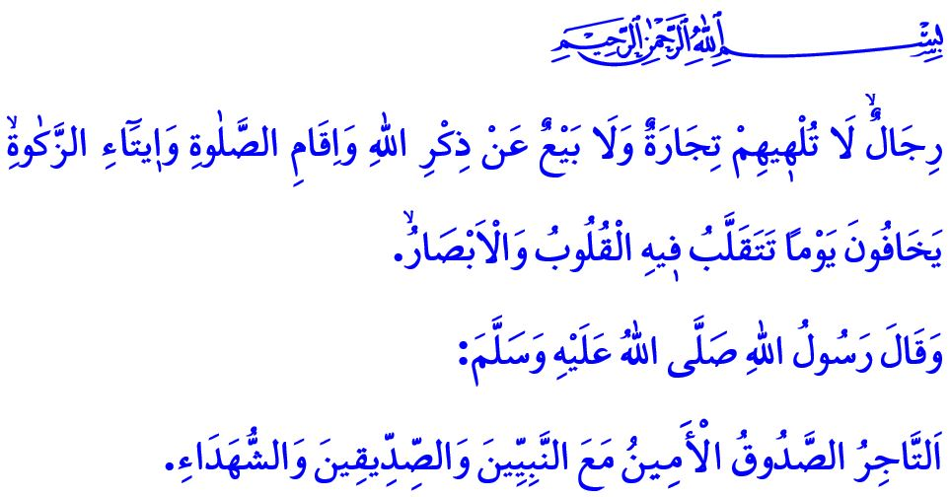OUR PROPHET (SAW) AND THE ETHICS OF TRADE
Honorable Muslims!
One day, a companion came into the presence of our beloved Prophet (saw) and said, “O Messenger of Allah! I am engaged in trade. When I buy goods, I initially state a lower price and gradually increase it. When I sell, I start with a higher price and then lower it. Is what I am doing correct?” Upon this, the Messenger of Allah (saw) said, “Never act in the manner you described! If you are going to buy something, state its actual price —whether they give it to you or not. And if you are going to sell something, state its actual price —whether they buy it or not.”
Dear Believers!
One of the significant matters emphasized by our sublime religion, Islam, is the ethics of trade. At the core of the trade ethics commanded by Islam lies a deep sensitivity to what is lawful (halal) and unlawful (haram). In accordance with the verse, وَاَق۪يمُوا الْوَزْنَ بِالْقِسْطِ وَلَا تُخْسِرُوا الْم۪يزَانَ “Weigh with justice, and do not give short measure,” establishing justice in measurement and weighing is essential. It is also essential to uphold truthfulness and integrity and to refrain from resorting to lies and deception.
Esteemed Muslims!
The best example for us in our commercial life is the Messenger of Allah (saw), who himself was engaged in trade. Even before his prophethood, he was known as Muhammad al-Amin, meaning Muhammad the Trustworthy. Our beloved Prophet (saw) encouraged hard work and earning through halal means, and he did not approve of laziness or begging. He warned those who tamper with their scales in trade, who allow lies to stain their words, or who mix haram into their earnings with the punishment of Hellfire.
Dear Believers!
Unfortunately, today we are witnessing the very times foretold by the Prophet (saw), when he said, “Certainly a time will come when people will not bother to know from where they earned the money, by lawful means or unlawful means.” Some people, driven by the desire to earn more and to become wealthy through shortcuts, have lost their sensitivity to what is halal and what is haram. According to Islam, to misrepresent a product, to engage in black-market dealings, usury, and hoarding are acts of violating people’s rights and are haram. Failing to fulfill a promise, or committing to something one cannot deliver, is falsehood and a sin. Applying different prices to locals and foreigners in buying and selling is deception and a sin. Taking advantage of times of hardship, such as natural disasters, students’ school terms, or public servants’ designation periods, to raise rents or product prices is an infringement upon the rights of others and a grave sin.
In trade, knowingly concealing the defects of goods being sold, or taking advantage of a seller’s lack of knowledge or difficult circumstances to purchase an item below its true value, is opportunism and a betrayal of one’s labor. The warning of our Prophet (saw) is perfectly clear: “The Muslim is the brother of another Muslim, and it is not permissible for a Muslim to sell his brother goods in which there is a defect, without pointing that out to him.”
Honorable Muslims!
Our noble nation has carried the noble character of the Messenger of Allah (saw) into the realm of commerce through the Akhi organization. Akhi organization is a spiritual institution where goodness was woven upon the loom, where sweat of the brow meets prayer, and where earnings accumulate not only in the pocket but also in the heart. As our Almighty Lord states, “...by men who are not distracted—either by buying or selling—from Allah’s remembrance, or performing prayer, or paying alms-tax. They fear a Day when hearts and eyes will tremble,” they are a community of individuals whose hearts are engraved with faith, people who do not abandon their worship for the sake of trade. What falls upon us today is to once again let the spirit of akhi understanding prevail in our trade. It is to strive to earn our sustenance through halal means. Let us remember: the blessing of trade lies in honesty, its peace lies in what is halal, and its true gain lies in seeking the pleasure of Allah.

I would like to conclude this Friday’s khutbah with the following glad tidings of our beloved Prophet (saw): “The honest and trustworthy merchant will be together with the Prophets, the truthful, and the martyrs on the Day of Judgment.”

Ibn Majah, Tijarah, 29.
Rahmân, 55/9.
Bukhari, Buyu’, 23.
Ibn Majah, Tijarah, 45.
Nûr, 24/37.
Tirmidhi, Buyu’, 4. General Directorate of Religious Services

